## Project Name: Make an E-commerce Website for Sporty Shoes.

## Output:

### Homepage:

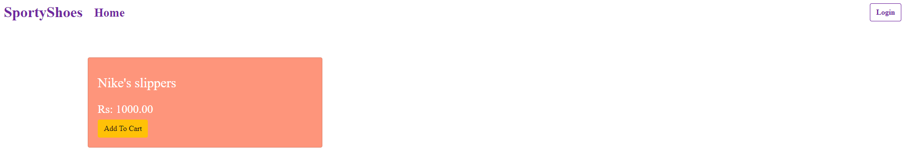

### Login Page:

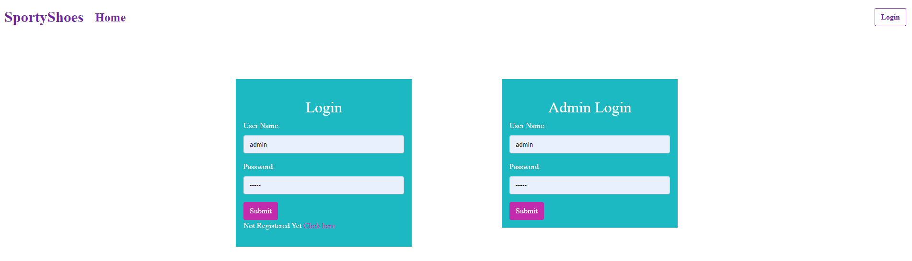

### Admin Dashboard:

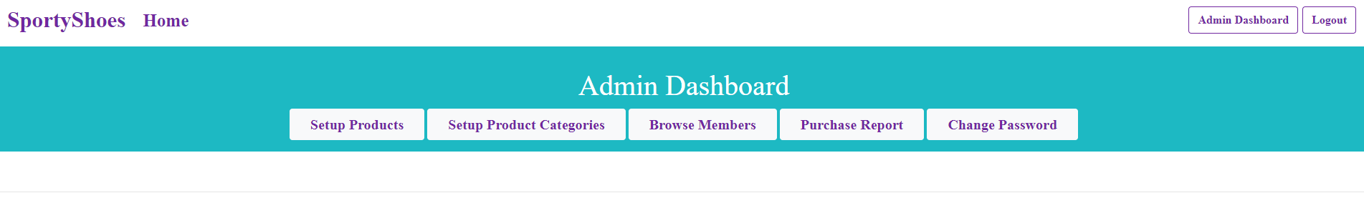

### Setup Product Category:

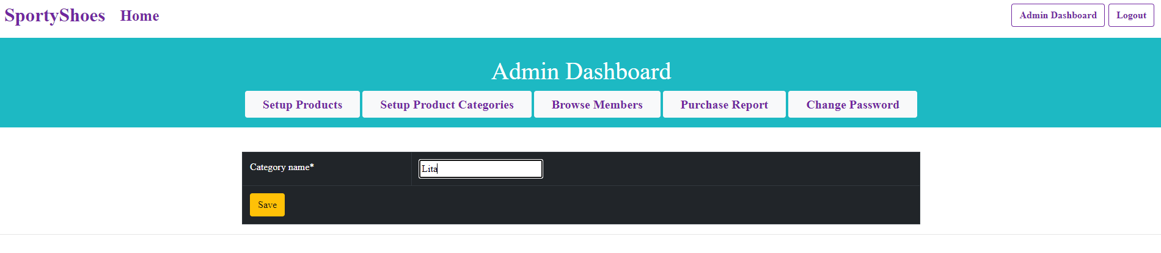

## Showing Category:

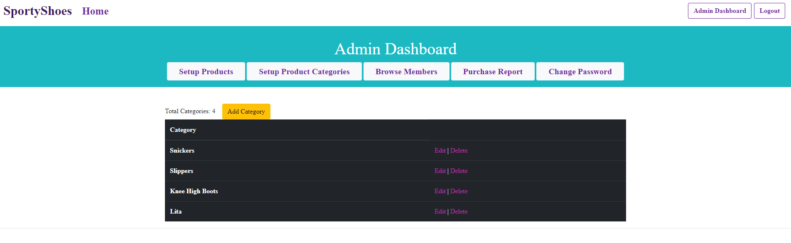

### Product Addition:

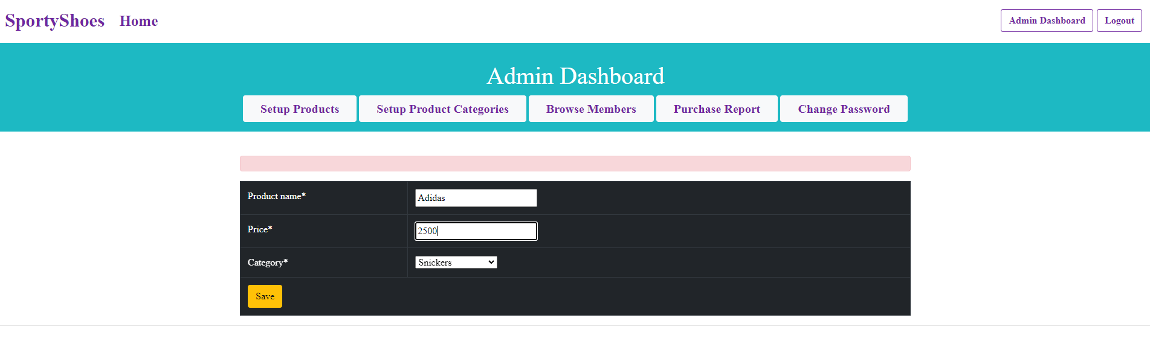

### Showing Product Details:

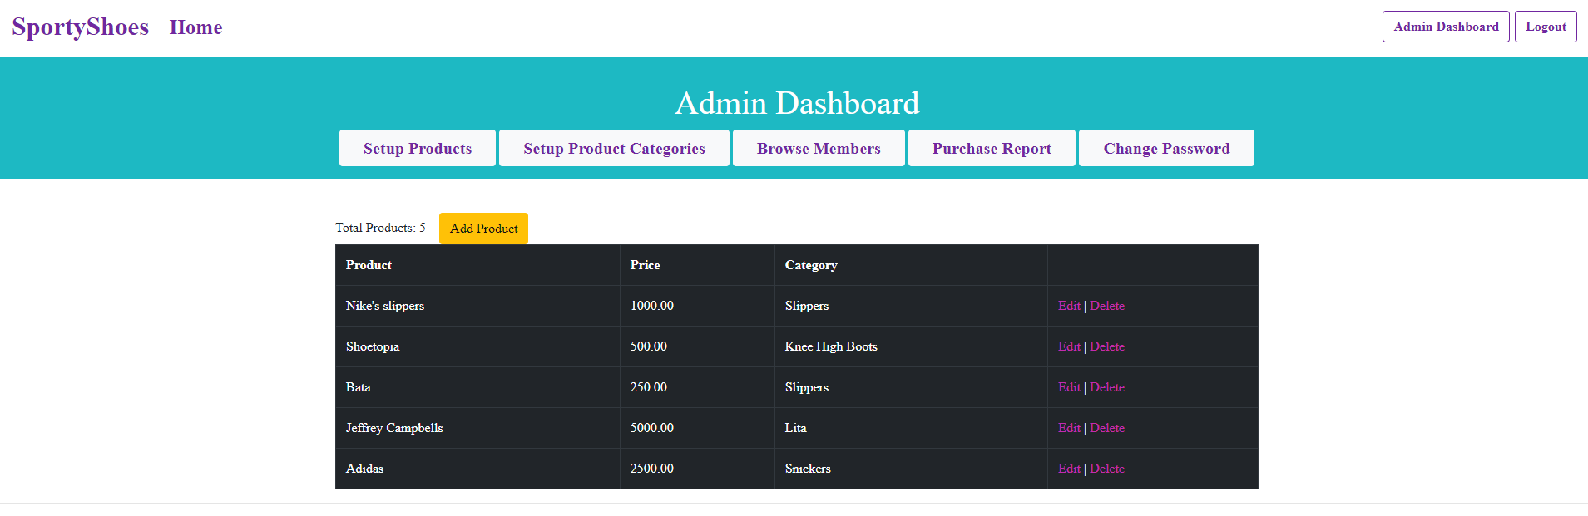

### Browse Members:

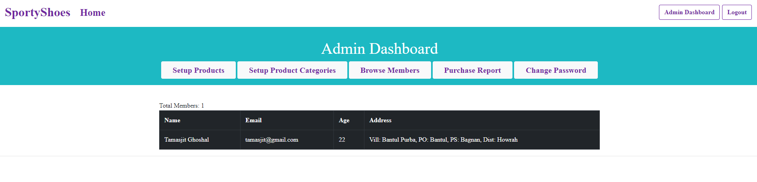

### Purchase Report:

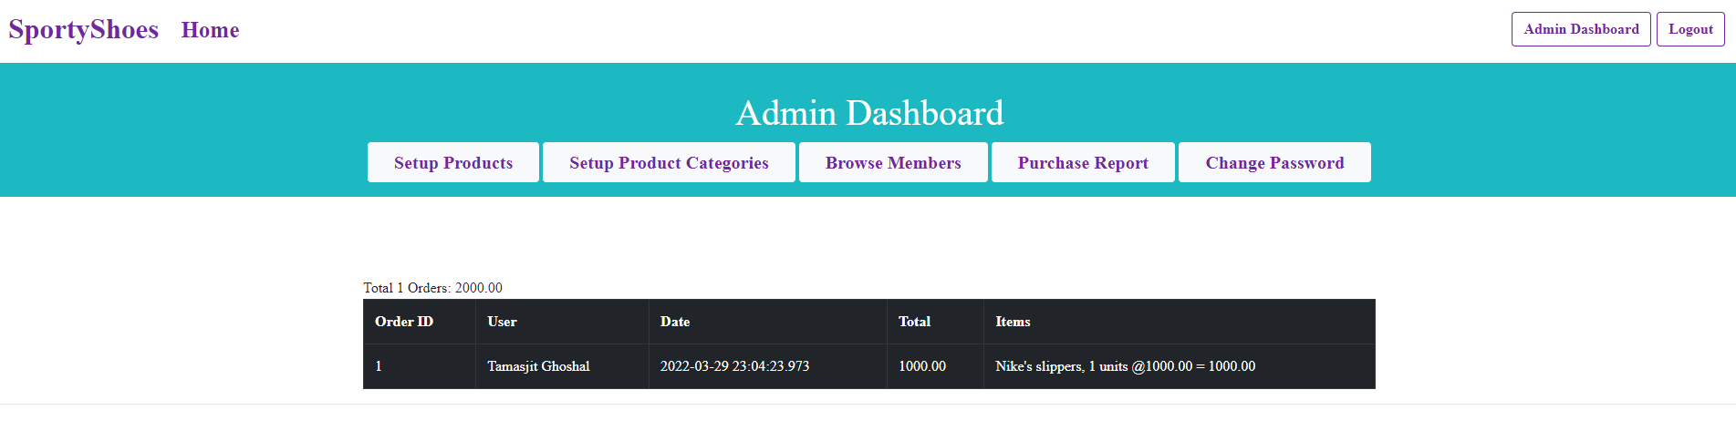

### Admin Password Change:

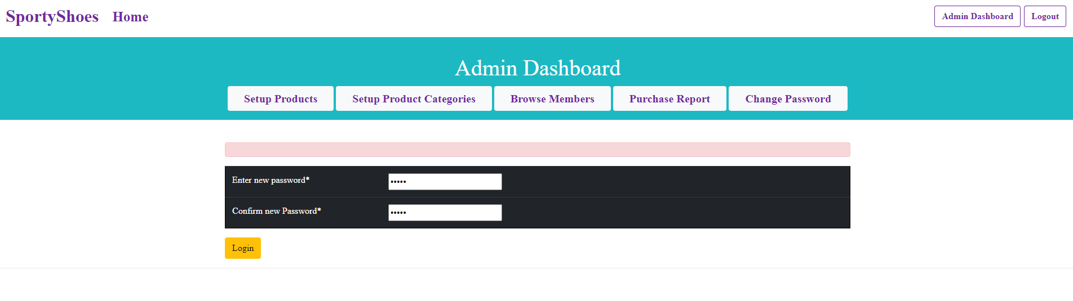

### New user Registration:

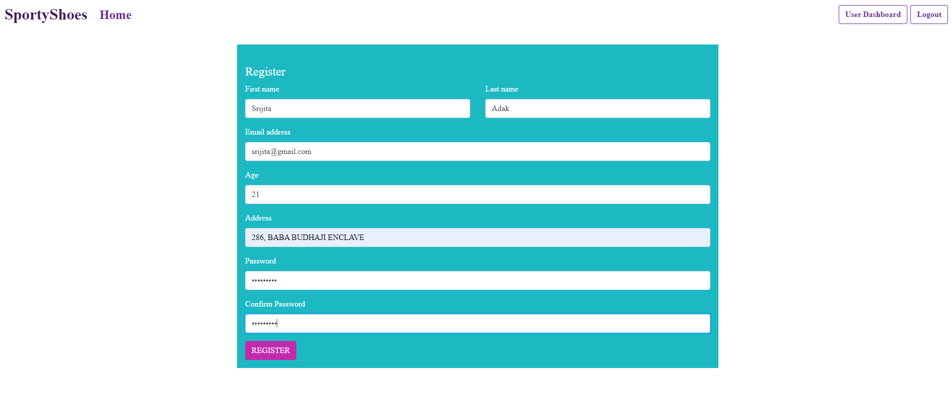

### After Creation:

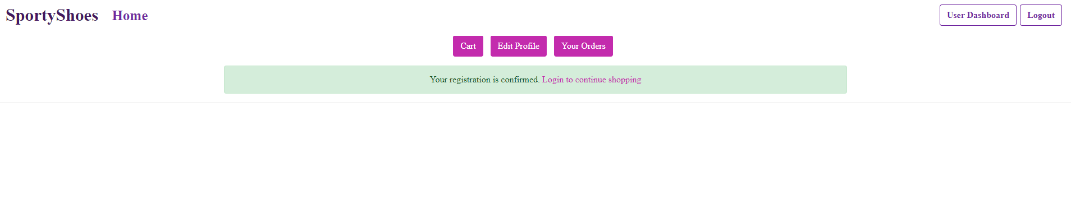

### Shopping Cart:

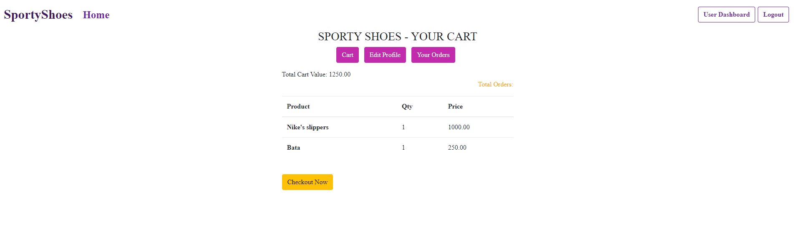

### Shopping checkout:

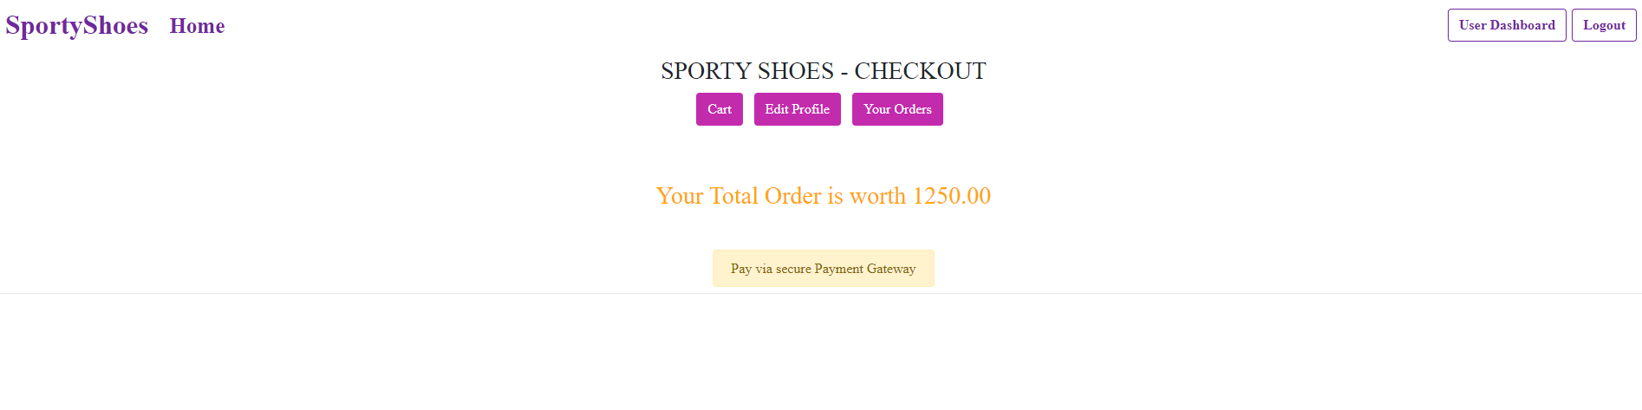

### Payment Gateway:

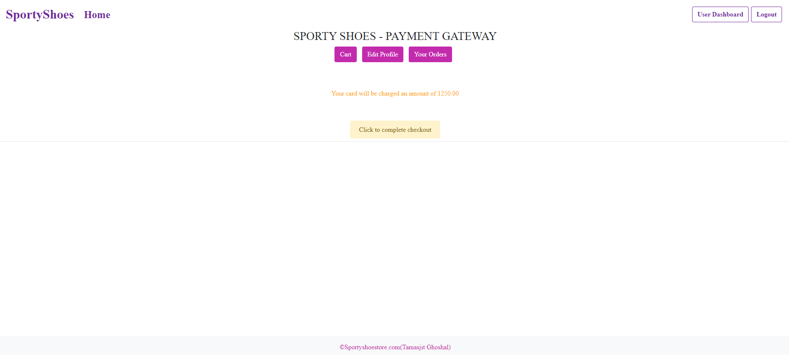

## Past Orders:

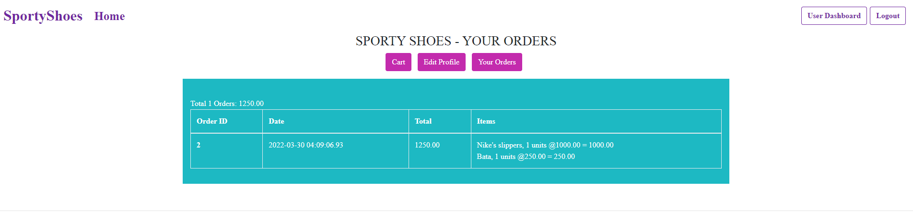

## Home Page after all process:

